**Art Gallery Management System**

Table of Contents

Modules: 2

Scope: 2

Mission Statement: 3

Task Assign To Members: 3

Zahir Ayub And Jamal Khan: 3

Nauman Ali And Shan e Ali: 7

## Modules:

* **Art products**
* **Artists information**
* **Costumer information**
* **Payment method**
* **Online order**

### Scope:

**1) The application will allow for registration of artist and customer**

**2) The application will allow for addition of product by artist**

**3) The application will allow customer to access list of products**

**4) The application will allow for addition, deletion or update of product from list.**

**5) The application will allow the customer to order and pay for product**

**6) The application will allow to search for product**

### Mission Statement:

Online Art gallery management system is an application that allows buyers to purchase paintings, scriptures, models online. The purchase is just a click away, you don’t have to go to some old museums and buy from selected stuff.

This application will provide you with a wide range of choices. The registration in this application is free, unlike other sites. It provides various categories too, in buyers’ accordance.

It provides free home delivery to buyers. It allows users to create their own portfolio.

# Task Assign To Members:

## Zahir Ayub And Jamal Khan:

Art Product:

This module will allow artist to add, delete and update his product it will allow customer to search products.

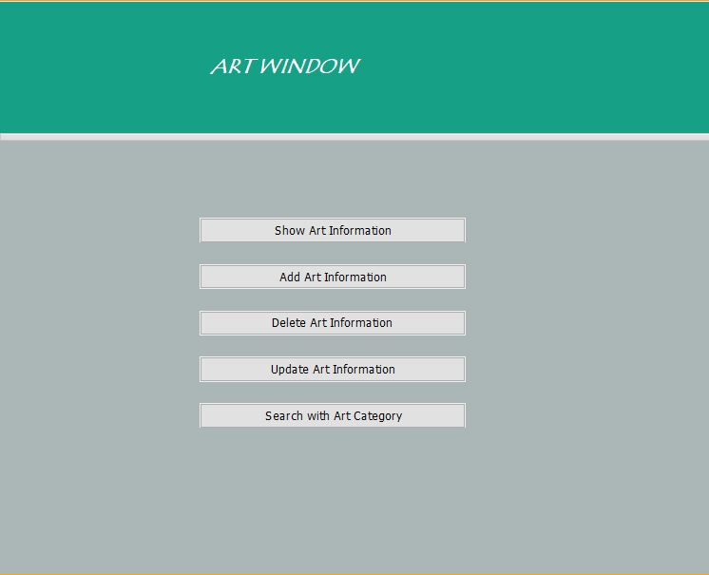

Artist Information:

This module will allow artist to save his information such as phone number, cnic and address. It will update his address and phone number also allow him to delete his record.

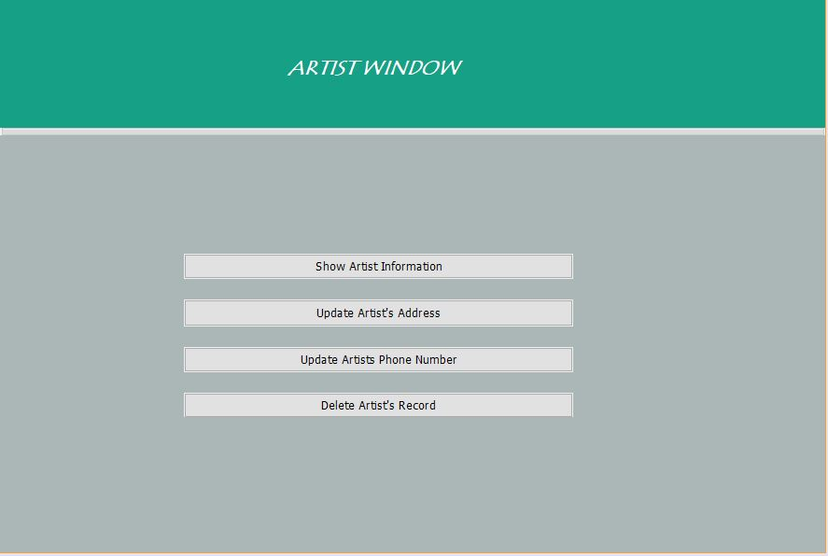

Customer Information:

This module will allow customer to save his information such as phone number, cnic and address. It will update his address and phone number also allow him to delete his record.

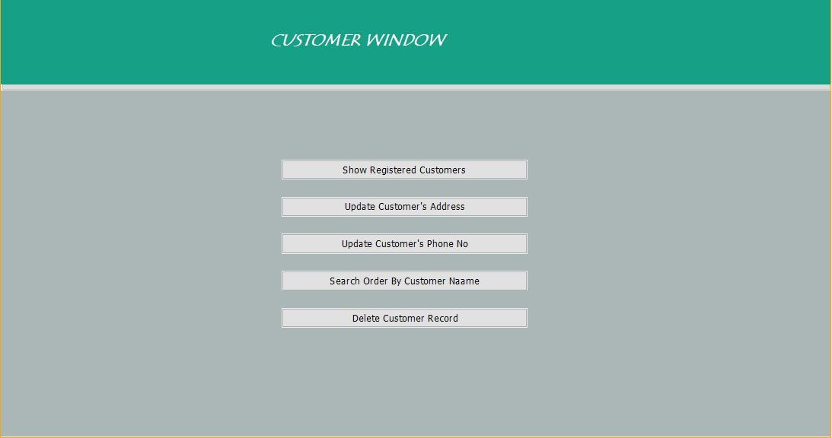

## Nauman Ali And Shan e Ali:

Payment Method:

It will Shows Payment details of all the products by details and display this months income.

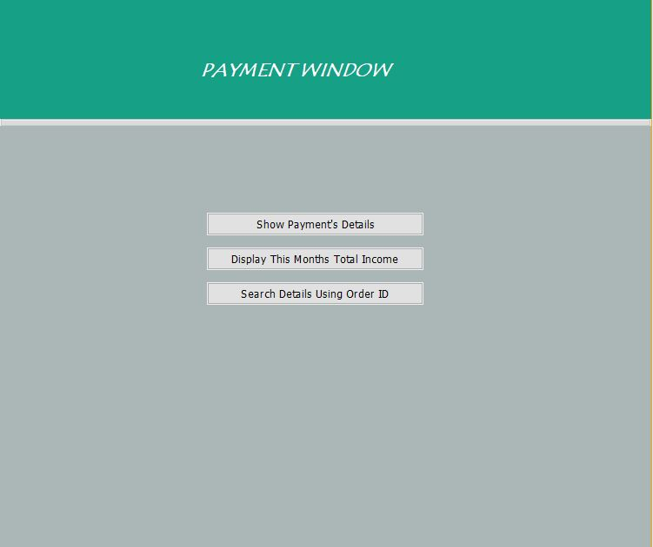

Online Order:

It will show the user what he/she is odering and also shows how much you ordered and final Total amount of all products you ordered and have a trace order facility as well.

